**CONTENTS**

* 1. **Official Launch and conduct of the Household Budget Survey**

**1.2** **Historical Perspective**

**1.3** **General Framework of the 2008 09 HBS**

**1.4** **Conceptual and Technical Basis**

**1.5** **Innovations and Improvements used in 2008 09 HBS**

**1.6** **HBS Timeline**

**1.7** **HBS Stakeholders Committee**

**2.1** **Objectives of the HBS**

**2.2** **Survey Subject**

**2.3** **Coverage**

**2.4** **Respondents**

**2.5** **Consumption Expenditure**

**2.6** **Measurement of consumption Expenditure**

**2.7** **Nomenclature - new**

**2.8** **Data collection**

**2.9** **Location of Selected Households**

**2.10** **Reference Periods**

**3.1** **Cabinet Approval**

**3.2** **HBS Unit**

**3.3** **Budget and funding**

**3.4** **Pilot Test**

**3.5** **Recruitment of Field and Processing Staff**

**3.6** **Training**

**3.7** **Publicity**

**3.8** **Tokens**

**3.9** **Quality Control Field Operation**

**3.10** **Workload Preparation and Distribution**

**3.11** **Receipt and Evaluation of Fieldwork**

**3.12** **Fieldwork**

**3.13** **Duties and Responsibilities of Field Supervisor**

**3.14** **Duties and Responsibilities of HBS Enumerators**

**3.15** **Printing of Questionnaires**

**4.1** **Questionnaire Design, Content and Layout**

**4.2** **Development of 2008-09 HBS Questionnaires**

**4.3** **Household Questionnaire HBS 1**

**4.4** **Individual Questionnaire HBS2**

**4.5** **Diary HBS3**

**4.6** **Main Food Purchase Form HBS4**

**4.7** **Supplementary Form - Other Social Programmes HBS5**

**5.1** **Sample Frame**

**5.2** **Income Area**

**5.3** **Sample Size**

**5.4** **Sample Design and Selections by Region**

**5.5** **Substitution**

**6.1** **Errors in Surveys**

**6.2** **Non Response Rate**

**6.3** **Standard Errors and Design Effects**

**7.1** **Spender**

**7.2** **Expenditure**

**7.3** **Disbursements**

**7.4** **Income**

**7.5** **Sources of Household Income**

**7.6** **Household Receipts**

**7.7** **Gifts**

**7.8** **Home Produced Food**

**7.9** **Area purchased or paid**

**7.10** **Person who paid for the Item**

**7.11** **Method of Payment**

**7.12** **Type of Outlet**

**7.13** **Urban-Rural Definition**

**7.14** **Imputed Rent**

**7.15** **Other Concepts and Definition**

**8.1** **Introduction**

**8.2** **HBS Processing System**

**8.3** **Image Capture System**

**8.4** **Intelligent Classification and Coding Systems**

**8.5** **Hardware used**

**8.6** **Processing Staff**

**8.7** **Number of Documents Processed**

**8.8** **Main Processing Activities**

**8.9** **Gross Imputed Rent**

**8.10** **Other Processing Activities**

**9.1** **Problems Encountered**

**9.2** **Recommendations for improvements**

**1.1 Official Launch and Conduct of the Household Budget Survey**

The 2008/09 Household Budget Survey (HBS) was officially launched by the Minister of Planning, Housing and the Environment, Dr. the Honourable Emily Dick-Forde on Friday 2nd May 2008 at the Crowne Plaza Hotel.

The fieldwork for the HBS commenced on Sunday 4th May 2008 and was completed on 30th April 2009 with an initial sample size of 7, 680 households however due to non-response by households the realized sample size was 7, 090 with an overall non-response rate of 7.7%. The Household Budget Survey (HBS) sample comprised twelve (12) monthly representative sub-samples which were further divided into twenty-four fortnights or periods of enumeration spread across twelve (12) months to take into account the effects of seasonality on expenditure patterns.

**1.2** **Historical Perspective**

The Central Statistical Office has historically conducted Household Budget Surveys (HBS) formerly called Household Budgetary Surveys. However these surveys have been conducted in a sparse and infrequent manner with varying time gaps between surveys as well as data collection periods.

The first Household Budget Survey to be carried out in Trinidad and Tobago was conducted in 1957. The second survey was undertaken thirteen years later during August 1971 to September 1972. The third HBS was conducted three years later between 1975/1976 and the fourth survey five years after from 13th September 1981 to 8th May 1982. The fifth HBS was carried out six years later over the period 6th March to 20th August 1988 while the sixth HBS was conducted from 18th May 1997 to 16th May 1998 after a ten year period. The 2008/09 Household Budget Survey (HBS) is the seventh and latest such survey to be conducted by the Central Statistical Office.

**1.3** **General Framework of the 2008/09 HBS**

The current HBS is the most comprehensive in terms of coverage, statistical reliability and timeliness conducted to date in Trinidad and Tobago

The general framework of the operations of the 2008/09 HBS was such as to support the delivery of a very high quality statistical product. As such the current HBS exercise exemplified the following:

* A high quality statistical product.
* A vastly improved HBS as compared with the previous.
* Adherence to International Methodology and Best Practises.
* The timely completion and dissemination of reports.
* Stake Holders Involvement
* Facilitation of the use of HBS Data.

**1.4** **Conceptual and Technical Basis**

Household Budget Surveysare very complex household surveys. The 2008/09 HBS utilized three (3) questionnaires and a diary for collecting information. Underlying this survey is a complex collection of concepts and definitions that can be quite challenging consequently it is critical that the technical and conceptual basis underlying this survey be robust and current along international recommendations. The elements that define the technical and conceptual basis of the current HBS are as follows:

* Technical Report on the 1997/98 HBS and main recommendations.
* Historical and International HBS Methodology.
* Current Best Practices in HBS.
* ILO Resolution on the Compilation of Income and Expenditure Statistics (2003).
* The Success Template of the 2004 Agricultural Census.
* Stakeholders involvement.

**1.5** **Improvements and Innovations utilized in the 2008/09 HBS**

A number of improvements and innovations were introduced in the 2008/09 Household Budget Survey to enhance the quality, timeliness and usefulness of the HBS data. Principally amongst these were the following:

1. **Sample Size and Design**

* The sample size of 7, 680 households was determined at a stated level of statistical reliability such that estimates of expenditure would carry a margin of error of 3%.
* Sample was composed of twelve (12) monthly nationally representative sub-samples.
* The frame used was the 2000 Population and Housing Census. The only other available frame was the Continuous Sample Survey of Population (CSSP) master sample however this has not been revised since the 1990 Population and Housing Census.
* Income Area – the sample within each region was sub-divided into high, middle and low income areas there by providing an invaluable variable for data analysis below the level of the region.

1. **New Expenditure Classification**

* The previous expenditure classification used in the last HBS was replaced by a new classification based on the Classification of Individual Consumption Expenditure by Purpose (COICOP) modified for Household Budget Surveys which was specifically developed for the current HBS.
* This new classification permits six (6) levels of disaggregation and carries a 10 digit code.

1. **Improved Coverage of Expenditure Items.**

* The 2008/09 HBS documents were designed to collect expenditure information on approximately 1,563 consumption expenditure items as compared with 806 as in the previous HBS.
* The number of food items including alcoholic and non-alcoholic drink covered has been increased from 290 to 705.

1. **Survey Instruments**

* User friendly questionnaire design with lead-in questions to facilitate easer enumeration.
* HBS questionnaires were designed for image capture (Scanning).
* HBS questionnaires were designed to capture a far greater level of detail than previously resulting in improved coverage.
* Inclusion of additional variables for analysis such as Single Parents, Disability, Chronic Illness, Economic Contributor, Employment Status, Social Programmes, Pets, Mortgage Institution, Outstanding Debt, Type of Outlet and identification of the person who purchased the item.
* A redesigned and vastly improved Diary.
* Main Food Purchase Form – to improve the reporting of expenditures on food, drink and tobacco.

1. **Processing**

* Image Capture Processing System.
* Computerised driven editing and coding environment.
* Automatic coding of Diary and Main Food Purchase Forms comprising a linkage of text and code.

1. **Data Dissemination**
   * HBS Reports produced on CDs
2. **Quality Assurance Programme for Field Operations**
   * Regular field visits in both Trinidad and Tobago by subject matter personnel.
   * Preliminary assessment and grading of incoming work (*some work were determined as unsuitable for processing*).
   * Frequent meetings with Supervisors.
   * Meetings with errant Enumerators reinforcing concepts and definitions.
   * Return of unsuitable documents to the field.
3. **Urban/Rural Definition**

* An improved definition of Urban/Rural Area.

1. **Revised Definition of Spender**
   * The definition of a spender was revised from that used in the previous HBS. Spenders were defined as persons who were 7 years old and above and spent at least $100 dollars a month. This revised definition was introduced so as to collect information on the expenditure patterns of young persons.
2. **The Person who Purchase (Paid) for the Item**
   * Information was collected so as to identify the person who purchased or paid for each item. This information would facilitate analysis of individual expenditure patterns.
3. **Type of Outlet**
   * Information was collected on the type of outlet where items were purchased. This data would enable a more accurate separation of expenditures on items normally sold at more than one type of outlet such as market produce sold in supermarkets etc.

**1.6** **HBS Timeline**

June 2006 Draft HBS Proposal Completed by the CSO.

September 14th 2006 Cabinet Approval granted for the Conduct of the HBS.

January 2007 Interim HBS Unit was established.

September 2007 Official HBS Unit Created.

October 2007 Upgraded Teleform System

November 2007 Pilot Test Conducted

December 2007 Secured external IT Support to Finalize the HBS Processing System

March 2008 Recruitment of HBS Field Staff

April 2004 Training of HBS Field Staff

May 2nd 2008 Official Launch

May 4th 2008 Start of Field Work

May 8th 2008 Extension of Life of the HBS Unit to Sept 30th 2009.

May 19th 2008 Start of Editing and Coding of Documents

June 15th 2008 Start of Scanning and Verification

October 31st 2008 Re-Training of HBS FieldStaff.

November 2008 Final Batch of Questionnaires Printed

March 9th 2009 Start Validation of Diaries.

May 15th 2009 Completion of Field Work

November 2009 End of Processing

December 2009 Completion of HBS Reports.

December 2009 Publish HBS CD

**1.7** **HBS Stakeholder’s Committee**

A HBS Stakeholder’s Committee was formed to obtain input from data users in the development of the survey questionnaires and tabulations. The HBS Stakeholders represented a broad cross section of data users comprising representatives from international organisations, government ministries, the University of the West Indies, private sector researchers, trade unions and consumer groups. This committee held six (6) meetings prior to the start of the HBS field operations. Input from this committee with respect to questions, responses and formatting were incorporated into the final HBS questionnaires.

**2.1** **Objectives of the HBS**

The major Objectives of the 2008/09 Household Budget Survey were as follows:

* To collect information for the selection of a current basket of goods and services for the revision of the Index of Retail Prices.
* To revise the section weights of the Index of Retail Prices.
* To provide extensive data on household budgets - incomes and expenditures.
* To provide data on the distribution of household income and expenditure.
* To provide data on Area Purchase *(area where items are purchased).*
* To provide data on the Type of Outlet where items are purchased.
* To facilitate the construction of poverty lines, the conduct of poverty analyses and myriad social research activities to inform policy formulation.
* To supplement the data used for National Accounting purposes.

**2.2** **Survey Subject**

The core subject matter of the 2008/09 Household Budget Survey comprised the following:

1. Demographic, socio-economic and related information of household members
2. Access to Social Programmes
3. The household budget – income, consumption expenditure and non-consumption expenditure
4. Household receipts and disbursements
5. Area purchased
6. Type of Outlet
7. Housing conditions
8. Availability of durables and facilities.
9. Household Debt

# 2.3 Coverage

The 2008/09 Household Budget Survey was a nationally representative survey with coverage across all cities, boroughs and regions in Trinidad and Tobago.

*Trinidad*

City of Port of Spain

City of San Fernando

Borough of Arima

Borough of Chaguanas

Borough of Point Fortin

Diego Martin Regional Corporation

San Juan/Laventille Regional Corporation

Tunapuna/Piarco Regional Corporation

Sangre Grande Regional Corporation

Mayaro/Rio Claro Regional Corporation

Princes Town Regional Corporation

Couva/Tabaquite/Talparo Regional Corporation

Penal/Debe Regional Corporation

Siparia Regional Corporation

*Tobago*

Parish of St. George

Parish of St. Mary

Parish of St. Andrew

Parish of St. Patrick

Parish of St. David

Parish of St. Paul

Parish of St. John

**2.4** **Respondents**

# The respondents in this Survey comprised members of private households using the Central Statistical Office’s standard household definition. Individuals found living in boarding houses, hostels and institutions were excluded. Visitors who were staying with the household for a period of six months or more were included while household members who were away from the household for a period of six months or more were generally excluded except where the household incurred significant expenditures for those individuals or where the absence was work related.

**2.5** **Consumption Expenditure**

Consumption expenditure is expenditure on consumer goods and services, these refer to those goods and services acquired for the satisfaction of wants and needs of households and individuals.

Household consumption expenditure is the value of goods and services that were acquired (used or paid for) by the household for the direct satisfaction of the needs and wants of its members including items purchased as gifts for persons outside the household:

1. Through direct monetary purchases in the market.
2. Through the market but without using any money as means of payment (barter, income in kind).
3. From production within the household (own account production)

**2.6** **Measurement of Consumption Expenditure**

Consumption expenditures on all goods and services were measured using the acquisition costs approach with the exception of owner occupied dwelling services which was measured using the flow of services or consumption costs approach.

# 2.7 Nomenclature

The nomenclature used encompassed the range of household receipts and disbursements divided into the following main divisions:

1. Income from employment

2. Income from self-employment

3. Other income

4. All other household receipts

5. Consumption expenditure

6. Gifts received from other households

7. Own- production of agricultural products

8. Non- Consumption expenditure

9. All other disbursements

The nomenclature used for consumption expenditures was based on the Classification of Individual Consumption Expenditure by Purpose (COICOP) modified for Household Budget Surveys.

The COICOP is composed of twelve main divisions:

01 Food and non-alcoholic beverages

02 Alcoholic beverages, tobacco and narcotics

03 Clothing and footwear

04 Housing, water, electricity, gas and other fuels

05 Furnishings, household equipment and routine household maintenance

06 Health

07 Transport

08 Communication

09 Recreation and culture

10 Education

11 Restaurants and hotels

1. Miscellaneous goods and services

The Non-Consumption Expenditure and Income Classification is comprised of five main divisions:

1. Non-consumption expenditure
2. Disbursements other than expenditure
3. Income
4. Other receipts
5. Memorandum items

The HBS expenditure and income classification was specifically developed for the current HBS and comprised approximately 2000 items. The consumption expenditure classification permitted six levels of disaggregation Division, Group, Class, Sub-class, Item Type and Item. While the non-consumption expenditure and income classification included four levels of disaggregation Division, Group, Class and Item Type.

**2.8** **Data collection**

The fieldwork spanned a period of twelve months primarily to account for seasonality and was conducted via twenty-four fortnights with a new group of households being interviewed in each fortnight.

Data was collected via Interviewer administered questionnaires and self-administered diaries covering a two week period. Interviewers periodically checked and assisted household members with their recording.

**2.9** **Location of Selected Households**

Enumerators were not required to list Enumeration Districts prior to enumeration, as this is a very time consuming exercise and would of impact negatively on the quality of interviewing given the demanding HBS workload. The location of selected households was obtained by utilizing existing recent CSSP listings. Where such listings were not readily available Enumeration Maps or a quick area listing by supervisors were used for the selection of households

# 2.10 Reference Period

The Household Budget Survey utilized retrospective moving reference periods for recording expenditures in the household and individual questionnaires. The length of the recall period was related to the frequency of purchase and the need to minimize recall errors. As far as possible twelve (12) month retrospective moving reference periods were utilized in most sections. A fourteen day diary period was used to collect expenditures on food and non-alcoholic beverages, alcoholic beverages, tobacco, as well as certain purchases in restaurants and hotels. The diary fortnight began on a Sunday and ended on the second Saturday. The diary information was supplemented with a Main Food Purchase Form.

**3.1** **Cabinet Approval**

The conduct of the 2008/09 HBS and the creation of the HBS Unit to oversee the conduct of the Household Budget survey were approved by Cabinet Minute No. 2393 on 14th September 2006. The life of the HBS Unit was subsequently extended to the 30th September 2009 by Cabinet Minute No. 1145 dated May 8th 2008.

The HBS survey was originally schedule to start in March 2007 however due to delays in the recruitment of appropriately skilled staff the start was rescheduled to May 2008.

**3.2** **HBS Unit**

The Household Budget Survey Unit (HBU) was a separate unit created within the Central Statistical Office with responsibility for the conduct of the 2008/09 Household Budget Survey. The creation of this specialised temporary unit is not without precedent since such arrangements have been utilized successfully in the conduct of Population and Housing Censuses and the 2004 Agricultural Census. The HBS Unit was initially created for a period of twenty-two (22) months however the life of the unit was extended until 30th September 2009. to ensure the successful completion of the exercise. This unit was housed at 30 Park Street, Port of Spain in accommodations formerly used by the 2004 Agricultural Census unit. The HBS operations occupied the ground floor. The HBS unit was headed by the Senior Statistical Analyst and comprised professional and technical staff, field staff and administrative staff. The HBS unit comprise eighty seven (87) persons of which eighty one (81) persons comprising professional, technical and field staff were hired on contract. Diagram 3.1 Show the organizational structure of the HBS unit.

The Professional and Technical Staff comprised the following positions:

1 Senior Statistical Analyst

1 Statistical Analyst II

1 Statistical Analyst I

2 Statistical Technicians II

2 Temporary Clerical Assistants

1 Information Technology Specialist II

1 Information Technology Specialist I

10 Editors

10 Verifiers/Coders

2 Scanning Operators

The Field Staff comprised:

10 Supervisors

40 Enumerators

The Administrative Staff comprised:

1 Accounting Assistant

1 Clerk III

1 Clerk/Typist

1 Chauffeur/Messenger

1 Cleaner

1 Vault Attendant

Figure 3.1 shows the organization structure of the HBS Unit.

Figure 3.1 Organizational Chart of the HBS Unit



**3.3** **Budget and Funding**

The total estimated budget for the conduct of the 2008/09 Household Budget Survey over the period October 2006 to July 2008 was estimated to be $15.8 million with yearly financing requirements of $10.6 million for October 2006 to September 2007 and $5.2 million for the period October 2007 to July 2008.

Total salaries was estimated at $6.5 million, enumeration costs at $3.6 million, training costs $0.8 million, rental costs $1.6 million, equipment and supplies $2.4 million, publicity $1 million, printing and software requirements $2 million and dissemination $0.2 million.



**3.4** **Pilot Test**

The Pilot Test for the 2008/09 HBS was conducted during the period 15th October to 14th November 2007. The field and survey processing staff utilized comprised three (3) Supervisors, twelve (12) Enumerators and six (6) Editors/Verifiers. A total of ninety-six (96) households were enumerated utilizing the ratio of enumerators to households as planned for the main survey. Results of the Pilot Test were used to inform and improve the efficiency of the 2008/09 HBS in the following areas:

* Training
* Field Operations
* Design of Questionnaires and Other Survey Documents
* Survey Processing Operations

**3.5** **Recruitment of Field and Processing Staff**

The recruitment of field and survey processing staff was the responsibility of the Human Resource Division of The Ministry of Planning and Development. These positions were advertised and persons meeting the criteria of a combination of training and qualifications were selected for training. The number of applications was much smaller than expected. It was decided that a written evaluation after training would form the basis for final selection.

**3.6** **Training**

The training of field and survey processing staff was conducted during the period April 7 – May 02, 2008 by staff of the HBS Unit with invaluable assistance from Mr. A Beepath, Chief Census and Surveys Officer and Mr. Basook Mahadeo Principal Statistical Officer. Enumerators were trained over a three week period. The final selection of persons to work on the HBS exercise was based on a written assessment following which forty (40) Enumerators, ten (10) Supervisors and twenty (20) Editors/Coders/Verifiers were selected. A total number of sixty (60) persons were selected for training however a number of these persons left before the training was completed as such the HBS unit were just able to source the required number of enumerators.

**3.7** **Publicity**

The Communication Unit of the Ministry of Planning, Housing and the Environment was responsible for the publicity programme of the 2008/09 HBS. This programme started with the official launch of the survey. It comprised the placement of coloured advertisements in the daily newspapers and a jingle on a few selected radio stations up until September 2008. After which the publicity campaign quickly fell apart by October 2008 the HBS publicity had become completely non-existent. Further no progress was ever made with respect to the HBS brochures even though the draft brochures were prepared by the staff of the HBS unit before the start of the survey. Consequently majority of households were unaware of this survey which impacted negatively on the exercise. While the full impact is masked somewhat by substitution there was an oblivious reluctance to provide the necessary cooperation and fewer households were prepared to stay the full fortnight with the exercise.

**3.8** **Tokens**

Household Budget Surveys invariably carry a very high level of respondent burden mainly due to the size of the questionnaires and the fourteen (14) day diary recording period. In recognition of the heavy respondent burden of the exercise and to facilitate cooperation households were initially provided with tokens. Tokens comprising umbrellas and beach mats were distributed to households who cooperated. Most supervisors found that the tokens were very useful in facilitating cooperation in particular with respect to the keeping of Diaries. Unfortunately the provision of tokens was discontinued in October 2008.

**3.9** **Quality Control Field Operations**

As part of the quality control programme for the field operations the following were implemented.

* Regular field visits in both Trinidad and Tobago by subject matter personnel
* Preliminary assessment and grading of incoming work ( *some work is deemed as unsuitable for processing*)
* Frequent meetings with Supervisors
* Meetings with errant Enumerators reinforcing concepts and definitions.
* Return of unsuitable documents to the field.

**3.10** **Workload Preparation and Distribution**

HBS fortnightly workloads were prepared and distributed to field supervisors during the week preceding the start of each period of enumeration. This survey was divided in to twenty four periods of enumeration. Questionnaires, diaries, maps and other survey documents were packed into boxes which are carefully labelled by Period, Region and Enumeration District (ED). These boxes were collected by supervisors for onward transmission to enumerators and were returned to the office with the relevant documents after each period of enumeration.

**3.11** **Receipt and Evaluation of Fieldwork**

Incoming work for each period was received and evaluated at the time of submission. The deadline for the submission of fieldwork to the office was the Thursday following the end of each fortnight. Information for each household was evaluated and ranked at the time of submission. This was a critical component of the quality assurance programme of the HBS and often resulted in the instantaneous return of problematic work to the field for resolution.

The information for each household was ranked according to the number and type of questionnaires submitted as well as the level and quality of information contained. The following ranking was used.

Rank 1

Household Questionnaire

All Individual Questionnaire

Diary with information

And/or Main Food Purchase Forms

Rank 2

Household Questionnaire

50% Individual Questionnaire

Diary with information

And/or Main Food Purchase Forms

Rank 3

Household Questionnaire

At least one Individual Questionnaire

Diary with information

And/or Main Food Purchase Forms

Rank 4

Household Questionnaire

At least one Individual Questionnaire

Main Food Purchase Form

No Diary or diary with little information

Rank 5

Household/Individual Questionnaire

Diary with very little information

Rank 6

Household/Individual Questionnaire

No Diary

Rank 7

Other

Households ranked 5 to 7 were normally deemed to be unacceptable. These questionnaires were extremely problematic, contained little information of value and most could not be verified. To minimize editing and coding time as well as to avoid clogging the system with such documents, these households were dropped from the survey. In fact many of these households could be classified as technical non-response.

In cases where households were ranked 3 or 4 enumerators and supervisors were sent back to these households to obtain additional individual questionnaires.

**3.12** **Fieldwork**

The fieldwork for the 2008/09 HBS started on Sunday 4th May 2008 and ended on 30th April 2009. The field staff comprised forty (40) enumerators and ten (10) Supervisors. Thirty eight (38) enumerators were allocated to work in Trinidad and two (2) in Tobago on the basis of the sample distribution. An enumerator was assigned an average workload of eight (8) households per period comprising a cluster of four (4) households each in two Enumeration Districts. Overall a total sample of three hundred and twenty (320) was selected in each fortnight.

Over the twelve (12) month period of the fieldwork six (6) enumerators resigned for various reasons ranging from securing permanent employment to frustration due to the lack of publicity. The allocation of supervisors and enumerators by Region is shown in Table 1

**Table 1 – allocation of supervisors and enumerators by Region**

|  |  |  |
| --- | --- | --- |
| Region | Number of Supervisors | Number of Enumerators |
| Port of Spain | 1 | 2 |
| Diego Martin | 3 |
| San Juan/Laventille | 1 | 5 |
| Tunapuna/Piarco | 2 | 6 |
| Arima | 1 |
| Sangre Grande | 1 | 2 |
| Mayaro | 1 |
| Chaguanus | 2 | 2 |
| Couva | 5 |
| Princes Town' | 1 | 3 |
| San Fernando | 1 | 2 |
| Penal Debe | 3 |
| Point Fortin | 1 | 1 |
| Siparia | 3 |
| Tobago | 0 | 2 |

**3.13** **Duties and Responsibilities of the Field Supervisor**

The main duties and responsibilities of the Field Supervisor were as follows:

1. To supervise the work of the HBS Enumerators.
2. To Locate and make initial introductions to households.
3. Liaise with Household Budget Survey Unit.
4. Ensure the consistency and completeness of fieldwork in a timely manner.
5. Transport HBS Interviewers as required.
6. Conduct re- interviews.
7. Address all queries and meet with HBU staff as required.
8. Collect and return survey instruments according to a set timetable.
9. Follow all procedures as outlined in the HBS Field Manual.

**3.14** **Duties and Responsibilities of the HBS Enumerators**

The main duties and responsibilities of the HBS Enumerators were as follows:

1. Locate selected households.
2. Interview households and Individuals using HBS1- Household Questionnaire and HBS2- Individual Questionnaires.
3. Ensure the completion of the HBS Diary.
4. Complete HBS4 - Main Food Purchase Forms where applicable.
5. Ensure the consistency and completeness of all HBS questionnaires.
6. Resolve all inconsistencies with the survey respondents.
7. Ensure the timely completion of fortnightly workloads.
8. Meets with HBS Supervisor.

**3.15** **Printing of Questionnaires**

The printing of the HBS questionnaires were out sourced as the in house CSO printery did not possess the capability to digitally print the Barcodes required. Approximately one-half of the required questionnaires were printed over the period April to June 2008 while the remainder was delivered by November 2008.

The total quantity of questionnaires printed were

1. 8, 400 Household Questionnaire *HBS1*.
2. 22, 000 Individual Questionnaire *HBS2.*
3. 8. 000 Diaries *HBS3*

**4.1** **Questionnaire Design, Content and Layout**

Four (4) main documents were utilized for collecting information during the 2008/09 Household Budget Survey. These were the Household Questionnaire (HBS1), Individual Questionnaire (HBS2), Diary (HBS3) and the Main Food Purchases Form (HBS4). A Supplementary Form (HBS5) was introduced after the start of the survey to collect information on other social programmes that were not included in the Household Questionnaire (HBS1).

The structure, layout and content of the HBS questionnaires like other survey were determined by a number of factors. Primarily amongst these were the demands of the image scanning technology used for data capture and the detailed level of the nomenclature used for recording consumption expenditures of respondents.

Diagram 4.1 illustrates the main factors influencing the structure and content of the 2008/09 HBS questionnaires.

**Figure 4.1 Factors Influencing Structure and Content** 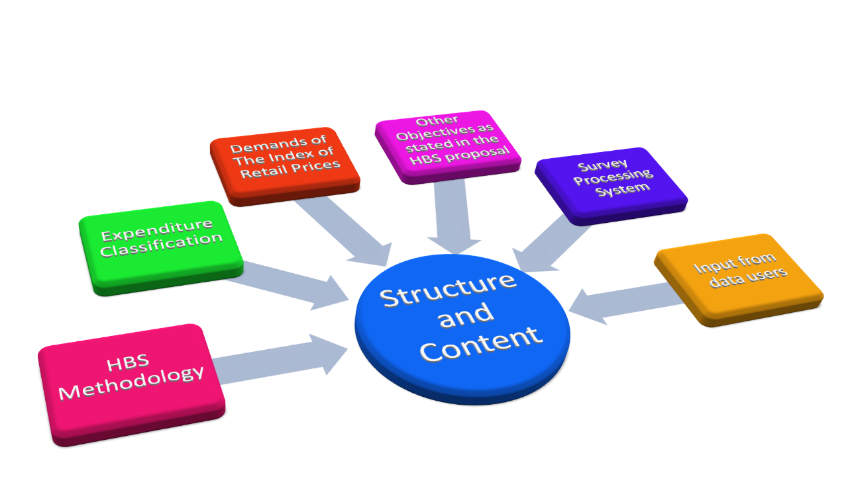

**4.2** **Development of the 2008/09 HBS Questionnaires**.

The 2008/09 HBS questionnaires were initially developed by the staff of the HBS Unit after which these documents were refined with input from the internal CSO HBS committee. Input from the HBS Stakeholder’s committee was incorporated and the documents were prepared for use in the Pilot Survey. The results of the Pilot Survey were used to refine and finalize the HBS questionnaires after which they were then sent to the printers. Diagram 4.2 presents the development path of the 2008/09 HBS questionnaires.

**Figure 4.2 HBS Questionnaire Development Path**

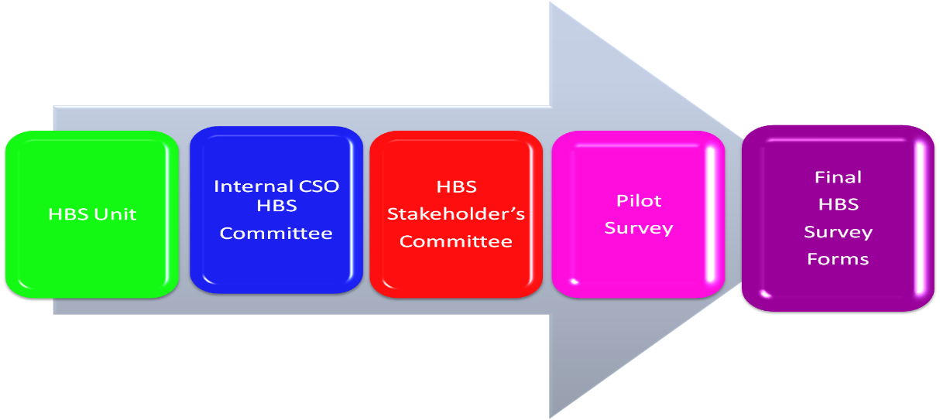

## 4.3 Household Questionnaire – HBS1

The Household Questionnaire was the first and most important document for collecting information in this survey. This questionnaire comprised thirty-two pages divided into seventeen (17) sections. It was used to collect demographic, social and economic data of household members as well as information on single parents, disability, chronic illnesses, access to social programmes, housing, facilities and durables owned or available for use, household pets as well as information on a range of household expenses. Information from this questionnaire was also used to identify the spenders in the household.

The expenditures collected in this questionnaire were expenditures related to the acquisition of household type goods and services. These are goods and services that are generally utilized by the household as a whole, as distinct from personal usage. This questionnaire was administered to the head of the household or a senior household member who could provide the necessary information.

**4.4** **Individual Questionnaire – HBS2**

The Individual Questionnaire was administered to spenders in the household who were fifteen years and above.This questionnaire collected information on the acquisition of goods and services that are usually used and enjoyed at an individual level such as clothing, clothing and footwear, medical goods and services, transportation, communication, education, accommodation services, recreation and culture, miscellaneous goods and services and personal gifts.

This questionnaire also collected information on non-consumption expenditure, individual debt, income and other receipts. Spenders were required to report all relevant expenditures that they have undertaken on the acquisition of goods and services regardless as to whether these were utilized by themselves or someone else.

## 4.5 Diary – HBS3

The diary formed a very critical part of this survey. It was specifically designed to collect information on the daily purchases of food, meals, drink and related expenses of the household and its members. It was kept for fourteen (14) days by a designated household member who accepted the responsibility to record the relevant daily expenditures of all spenders in the household on a daily basis. The diary also collected information on the purchasing patterns of the household which was used to determine if it was necessary to administer a Main Food Purchase Form to the household.

**4.6** **Main Food Purchase Form - HBS4**

The Main Food Purchase Form was designed as a supplement to the diary and represents an improvement in the collection of information on food expenditures. It was used to collect information on major purchases of food by the household which have already taken place or would be taking place outside the diary period of reporting and as such would not be recorded in the diary. It was introduced to address the problem of very few items recorded in the diaries of households who purchased their main food items outside the diary period and the consequence under reporting of food expenditures.

**4.7** **HBS Supplementary Form - HBS5**

The HBS Supplementary Form was used to collect information on other social programmes accessed by individuals that were not included in the Household Questionnaire (HBS1). This form was included as a special request after the start of the fieldwork.

**5.1** **The Sample Frame**

The 2000 Population and Housing Census listing of households by Enumeration Districts and Regions was used as the main frame for selecting the HBS sample. This was the only complete frame available at the time of conducting the HBS. Another possible frame was the Continuous Sample Survey of Population (CSSP) master sample however this source has not been revised since the 1990 Population and Housing Census and was clearly outdated.

**5.2** **Income areas**

The sample selected in each region was implicitly stratified by income area. The three categories of income area used were high, middle or low income area at the level of enumeration district. This variable was derived using income information from the 2000 Population and Housing Census which was adjusted for non-response and outliers. High income areas were determined as areas were the average income of persons in an Enumeration District (ED) was above the upper quartile of income, middle income areas were areas within the semi-inter quartile range while low income areas were those areas were the average income of persons in the Ed was below the lower quartile of income.

**5.3** **Sample Size**

The initial sample size for the 2008/09 Household Budget Survey HBS was 7, 680 households. This was determined as the sample size necessary so that the estimates of expenditure derived from the sample would have a margin of error of 3% after accounting for an expected 15% non-response rate. The realized sample was 7, 090.

# 5.4 Sample Design and Selection by Region

The sample design utilized was a stratified two stage cluster sample of households divided into twelve equal sub samples so that each sub sample was nationally representative by region and income area.

The sample was stratified by region to ensure a geographic representative sample of Trinidad and Tobago. Enumeration districts within regions formed the first stage, sampling unit while households within the selected enumeration district represented the second stage, or ultimate sampling units. The first stage sampling units were selected with probability proportional to size, in all one thousand nine hundred and twenty (1920) Enumeration Districts were selected this was equivalent to 80% of all Enumeration Districts. A compact cluster of four (4) households was then selected in each Enumeration District.

Each sub-sample was subdivided into two periods for ease of enumeration so that the total sample was spread across twenty-four periods or fortnights. Three hundred and twenty (320) households were selected during each period. Table 5.1 shows the sample selected for the 2008/09 HBS for regions by number of enumeration districts and number of households. Figure 5.1, figure 5.2 and figure 5.3 shows the distribution of enumeration districts selected in the sample by location, income area and sub-sample respectively.

Table 5.1 2008/09 HBS Sample Selection by Area

|  |  |  |
| --- | --- | --- |
| **Area** | **Number of Eds** | **Number of households** |
| **Trinidad and Tobago** | 1920 | 7680 |
| **Trinidad** | 1838 | 7352 |
| Port of Spain | 80 | 320 |
| Mayaro | 48 | 192 |
| Sangre Grande | 95 | 380 |
| Princes Town' | 132 | 528 |
| Penal Debe | 123 | 492 |
| Siparia | 125 | 500 |
| San Fernando | 90 | 360 |
| Arima | 47 | 188 |
| Chaguanus | 101 | 404 |
| Point Fortin | 32 | 128 |
| Diego Martin | 165 | 660 |
| Laventille San Juan | 257 | 1028 |
| Tunapuna | 307 | 1228 |
| Couva | 236 | 944 |
| **Tobago** | 82 | 328 |
| St. George | 8 | 32 |
| St. Mary | 4 | 16 |
| St. Andrew | 26 | 104 |
| St. Patrick | 22 | 88 |
| St. David' | 12 | 48 |
| St. Paul | 6 | 24 |
| St. John | 4 | 16 |

Figure 5.1 Location of Enumeration Districts Selected in the Sample

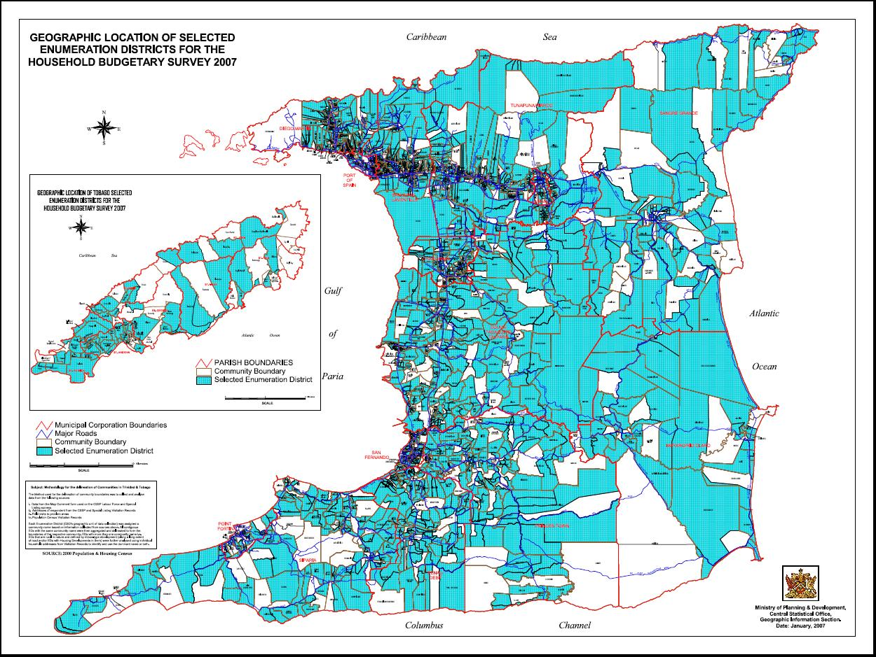

Figure 5.2 Distribution of Enumeration Districts by Income Area

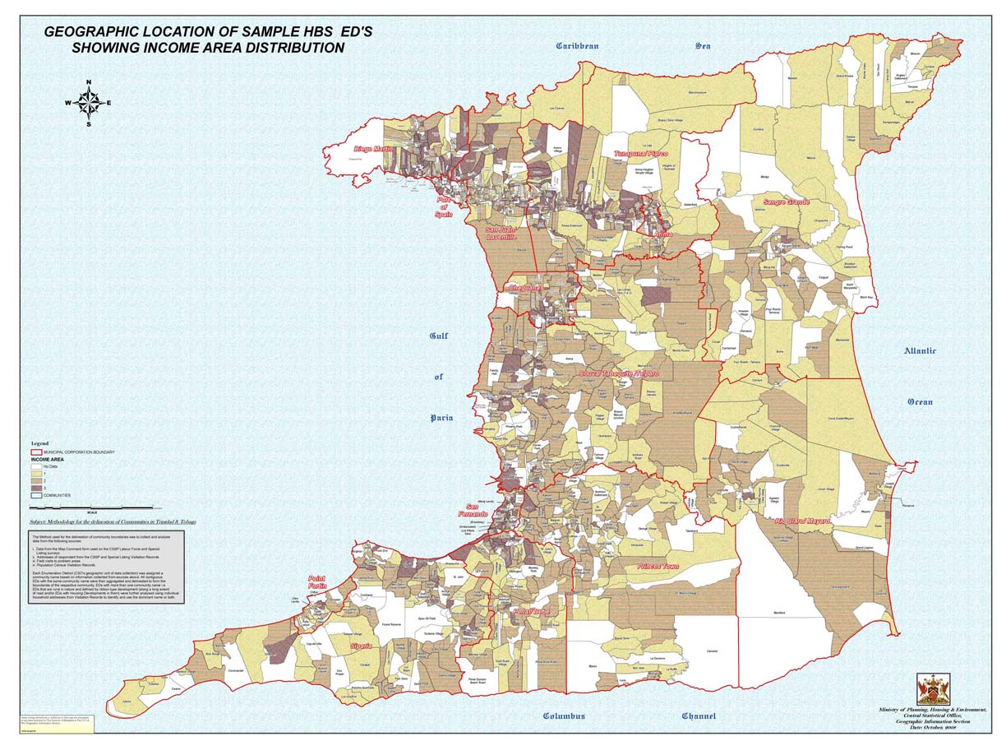

# Figure 5.3 Distribution of Enumeration Districts by Sub-Sample

# Subsample

# 5.5 Substitution

Household Budget Surveys normally experience much higher non response rates than the typical household survey obviously due to the large questionnaires used and the fourteen (14) day period of diary recording. In order to compensate for non-response substitution of none cooperating households was permitted. The rate of substation was ***** percent.

**6.1** **Errors in Surveys**

Information derived from surveys invariable contain some level of error, while every attempt has been made to minimize the occurrence of such errors it is impossible to eliminate all error. Errors in surveys are usually classified as either sampling or non-sampling errors.

**Sampling Error**

Sampling error is the error that is inherent in the use of sample estimates to draw conclusion about population parameters. Sampling error varies with the sample size, the larger the sample size the smaller the sampling error. It is impractical to expect that the values derived from any one sample will be equal to the ‘true’ population value consequently values derived from the HBS sample will vary to some degree from the “true” population values ( those values that would obtain if it were possible to enumerate all existing households ).

It is possible to quantify the extent of these errors taking into account the complex nature of the sample design.

**Non-sampling Errors**

Non-sampling errors are errors that arise due to respondent bias, interviewer bias and errors in processing. These errors are difficult to quantify, identify and correct.

The 2008/09 Household Budget Survey involved the collection of information from responses provided by households and their members hence to a very real extent the overall reliability and consistency of the 2008/09 household budget survey data depended largely on the cooperation of respondents and their willingness to provide the necessary information as required. Some households were reluctant to provide details on certain categories of expenditures, household characteristics and income. There were instances of telescoping errors (reporting of expenditures outside the reference periods), under reporting of expenditures, blank diaries and missing spenders. Households at the higher income levels were more inclined to refuse. A few enumerators were errant in the recording of information comprising the inclusion of digits where not required, misinterpretation of questions and neglect of certain questions.

A great deal of care and attention was devoted at the data collection and compilation stage so as to identify and minimize the occurrence of non-sampling errors. In this regard the staff of the HBS unit utilized a rigid quality assurance programme intended to identify, correct and prevent the occurrence of such errors as far as possible. The critical elements of the quality assurance programme comprised initial screening of incoming documents, the return of problematic documents to the field, regular field visits, technical support to fieldstaff, regular meetings with field supervisors, re-interviews of households, reinforcement of concepts and retraining of enumerators.

**6.2** **Non Response Rate**

The overall non-response rate was 7.7%. Households were classified as non-response in the following situations:

* The household refused and could not be substituted.
* The household could not be located and could not be substituted.
* No household questionnaire was completed.
* The information provided was sparse and highly inconsistent.

The non-response rate for Trinidad as a whole was 7.5%. The highest non-response rates while observed in Tunapuna/Piarco 10.7% and Diego Martin 10.6% while the Boroughs of Arima 3.7% and Chaguanas 4.0% reported the lowest rates. The non-response rate in Tobago was 12.5% (Table 6.1).

**Table 6.1 Non-Response Rates by Region**

|  |  |
| --- | --- |
| Region | Non Response Rate |
| Trinidad and Tobago | 7.7 |
| Trinidad | 7.5 |
| City of Port of Spain | 10.3 |
| Mayaro/Rio Claro | 9.9 |
| Sangre Grande | 10.3 |
| Princes Town | 10.2 |
| Penal/Debe | 4.1 |
| Siparia | 4.8 |
| City of San Fernando | 4.4 |
| Borough of Arima | 3.7 |
| Borough of Chaguanas | 4.0 |
| Borough of Point of Fortin | 4.7 |
| Diego Martin | 10.6 |
| San Juan/Laventille | 9.4 |
| Tunapuna/Piarco | 10.7 |
| Couva/Tabaquite/Talparo | 1.8 |
| Tobago | 12.5 |

The rate of substitution was 30.5%.

**6.3** **Standard Errors and Design Effects**

The standards errors and design effects were computed for expenditure items in the HBS using the SPSS Complex Sample Module. A transformed design was utilized for computational purposes that reflected the two-stage complex nature of the HBS sample design. The standard errors, standard error percent and design effects for expenditure items are listed in Appendix XXXIX.

**7.1** **Spender**

The basic spending unit in this survey was a spender. A spender was defined as a person who is seven (7) years and older and who normally spends at least $100 a month. Individual questionnaires were only completed for spenders 15 years and older.

**7.2** **Expenditure**

Total Expenditure in this survey comprised consumption and non-consumption expenditure.

**Consumption Expenditure**

Consumption expenditure is expenditure on consumer goods and services, these refer to those goods and services acquired for the satisfaction of wants and needs of households and individuals.

Household consumption expenditure is the value of goods and services that were acquired (used or paid for) by the household for the direct satisfaction of the needs and wants of its members including items purchased as gifts for persons outside the household:

1. Through direct monetary purchases in the market.
2. Through the market but without using any money as means of payment (barter, income in kind).
3. From production within the household (own account production)

**Non Consumption Expenditure**

Non consumption expenditure is expenditure incurred by households that do not result in the acquisition of any good or service for the direct satisfaction of its own needs i.e. payment of compulsory fees, fines, consumer interest payments, gifts and loans to other households etc.

Also included here are expenditures which are really in whole or part “savings” such as insurance premiums, sou sou, financial investments, etc.

**Business Expenses**

Since the survey covers only private households and is concerned with expenditure made by spenders as private individuals, it therefore excludes all business expenses.

**7.3** **Disbursements**

All household expenditures are included under disbursements. These include consumption expenditures non-consumption expenditures, such as fire insurance, annuities, repayment of loans, instalment payments, gifts and elements of current household savings.

**7.4** **Income**

Income consists of receipts in cash, in kind or in services that are received by persons on a regular and recurrent basis and which do not reduce their net worth.

**Household Income**

Household Income consists of Income after deductions for Income Tax, National Insurance, Pension and similar deductions as well as the value of imputed Rent, Home grown food and gifts received. Household income comprises both money income and imputed values.

**Gross Income**

Gross Income is income before deductions for Income Tax, National Insurance, Pension and similar deductions. Gross income refers to money income before deductions.

**Disposable Income**

Disposable income is Gross income less deductions for income taxes, National Insurance, Pensions and similar payments. It is the money income available to the household after deductions for income tax, national tax, pension and similar payments.

**7.5** **Sources of Household Income**

Income in this survey is obtained from the following sources:

1. Wages and salaries of employees including overtime, bonuses commissions and income in kind before deduction for Income Tax, national Insurance, Pension and similar payments.
2. Income from Self Employment

This is the income generated from the operation of a business or profession after deducting all business related expenses.

1. Income from Secondary Employment.
2. Income from Financial Investment.

This represents property income of households such as interest and dividends.

1. Annuities and pension
2. National Insurance Benefits
3. Income from Social programmes comprising Old Age Pension, Disability Grants, Public Assistance etc
4. Remittances from Abroad
5. Imputed Rent

Imputed Rent is an imputed value that is intended to measure the consumption of housing services by an owner-occupier or a person living rent-free. It is treated as both an income and expenditure item in this survey.

1. Home Grown Food

A value is estimated for the consumption of home grown food by households. This value is treated both as income and expenditure.

1. Gifts

Included in this category are monetary gifts, gifts, government and family allowances

1. Other Income

Rent, Income from roomers and boarders, Alimony/Child Maintenance, Financial assistance from other households income from other social programmes provided by NGO and any other income

**7.6** **Household Receipts**

Household receipts are the sources, monetary and non-monetary available to the household to facilitate consumption and non-consumption expenditures and household savings. Household receipts comprises household income together with other receipts such as insurance claims, sale of durables, loans of various types, receipts from games of chance and withdrawals made from savings.

**7.7** **Gifts**

**Gifts between Households**

Households often acquire goods and services by way of transfers from government, non-profit institutions and other households. A non-monetary gifts received by the household is treated as both an income and an expenditure of the receiving household.

**Gifts within Households**

Gifts between members of the same household are not considered as transfers, but as expenditure on the part of the purchaser.

**7.8** **Home Produced Food**

Home produced food is another means by which households may acquire consumer products other than from the market place. Home produced food is defined as all food grown, picked, reared or caught by any member of the household and consumed by the household during the past 12 months.

Agricultural produce grown by farmers that is not sold but is retained for use in the home is also included as home produced food.

**7.9** **Area purchased/paid**

Area purchased/paid refers to the community where an item or service was obtained (purchased/paid). In cases where an item or service was obtained from more than one area, the main area purchased/paid is to be reported based on value.

**7.10** **Person Who Paid for the Item**

Who paid for it refers to the household member who was mainly responsible for the purchase of a household item or service. For many purchases this would normally be the person who wanted the item and paid for it. A household member who paid for an item on behalf of another household member must not be recorded as the person who paid for it.

A housewife who shops at a supermarket/shop etc and pays for items with money provided by her spouse is recorded as the person who paid for it.

**7.11** **Method of Payment**

The method of payment describes the means of financing the acquisition of household durables which can be by cash, credit card, loan, hire purchase or other.

**7.12** **Type of Outlet**

The type of outlet refers to the type of establishment (retail and wholesale) where an item was purchased. It is applicable to the purchase of goods but not services. In cases were an item is purchased from more than one type of outlet the main type of outlet was used.

Type of outlet

1. Supermarket
2. Shop/parlour
3. Vendor – refers to someone who sells on the street or from a temporary stall.
4. Market
5. Poultry/meat shop
6. Bakery
7. Restaurant
8. Fast food outlet
9. Canteen
10. Bar/pub
11. Pharmacy
12. Household
13. Hardware
14. Paint Shop
15. Sand Pit
16. Furniture and Appliance Store
17. Specialized Store
18. Variety Store
19. Internet – refers to the actual use of the internet for transacting a purchase and not just for referencing information.
20. Government
21. Non-Government Organisation

99 Other

**7.13** **Urban/Rural Definition**

In the 1997/98 Household Budget Survey areas were classified as urban or rural at the level of the Ward based on population density per square kilometre. Wards where the population density was 200 or more per square kilometre were classified as urban with the exception of Siparia. Those Wards where the population density was less than 200 per square kilometre were classified as rural. This Urban/Rural definition was modified for the 2008/09 Household Budget Survey so as to better identify distinctly rural areas that were located within areas classified as urban. Communities within the urban areas (wards) were classified as rural based on the prevalence of a high level of agricultural activity measured as above the average number of agricultural holders per community and/or the median amount of hectares under agricultural cultivation as well as remoteness from main urban hubs. Consequently communities located in urban areas with forty (40) or more agricultural holders and/or at least forty eight (48) hectares under agricultural cultivation as reported in the 2004 Agricultural Census with an element of remoteness such as distance from main cities or difficult access were classified as rural.

Based on the revised definition the following areas were classified as Urban:

Port of Spain

San Fernando

Borough of Arima,

Borough of Chaguanas excluding the communities of Charlieville, Cunupia, Esmeralda, Felicity, Longdenville, Munroe Settlement, Petersfield.

Borough of Point Fortin,

Arima excluding the communities of Arima Heights/Temple Village,Carapo, Heights of Guanapo, La Laja, Maturita,Wallerfield.

Chaguanas excluding the communities of Arena, Caparo, Carlsen Field, Chandernagore, Longdenville, Mamoral No. 2, Palmiste,Ravine Sable, Todd's Road, Todd's Station, Welcome.

Couva excluding the communities of California, Indian Trial, Orange Valley.

Diego Martin excluding the communities of Cameron Road, Chaguaramas, Le Platte, Paramin.

Naparima excluding the communities of Barrackpore, Borde Narve, Debe Proper, Hermitage Village, La Fortune, Monkey Town, Penal, St Croix Village, St Johns Village.

Pointe-a-Pierre excluding the communities of Bonne Aventure, Caratal, Corosal, Farnum Village, Forres Park, Gasparillo, Guaracara, Mayo, Hermitage, Piparo, Poonah, Riversdale, Tortuga,Whiteland

St Ann’s excluding the communities of La Canoa, La Pastora, Maracas, Maracas Bay, Soconusco

Tacarigua excluding the communities of Acono Village, Caura, Kelly Village, La Paille Village, Lopinot Village, Maracas/St Joseph, Surrey Village.

All other areas were classified as rural consequently rural areas comprised the following wards and communities

Wards classified as rural:

Blanchisseuse, Cedros, Charuma, Cocal, Cunupia, Erin, Guayaguayare, La Brea, Manzanilla, Matura, Montserrat, Moruga, Ortoire, San Rafael, Savana Grande,

Siparia, Tamana, Toco, Trinity, Turure, Valencia and Tobago.

Communities classified as rural:

Borough Of Chaguanas

Charlieville, Cunupia, Esmeralda, Felicity, Longdenville, Munroe Settlement, Petersfield.

Ward of Diego Martin

Cameron Road, Chaguaramas, Le Platte, Paramin.

San Juan/Laventille - Ward of St. Anns

La Canoa, La Pastora, Maracas, Maracas Bay, Soconusco

Tunapuna/Piarco-Ward of Tacarigua

Acono Village, Caura, Kelly Village, La Paille Village, Lopinot Village, Maracas/St Joseph, Surrey Village.

Tunapuna/Piarco-Ward of Arima

Arima Heights/Temple Village,Carapo, Heights of Guanapo, La Laja, Maturita

Wallerfield.

Couva/Tabaquite/Talparo-Ward of Chaguanas

Arena, Caparo, Carlsen Field, Chandernagore, Longdenville, Mamoral No. 2, Palmiste,Ravine Sable, Todd's Road, Todd's Station, Welcome.

Couva/Tabaquite/Talparo-Ward of Pointe a Pierre

Bonne Aventure, Caratal, Corosal, Farnum Village, Forres Park, Gasparillo, Guaracara, Mayo, Hermitage, Piparo, Poonah, Riversdale, Tortuga,Whiteland.

Couva/Tabaquite/Talparo-Ward of Couva

California, Indian Trial, Orange Valley.

Penal/Debe-Ward of Naparima

Barrackpore, Borde Narve, Debe Proper, Hermitage Village, La Fortune, Monkey Town, Penal, St Croix Village, St Johns Village.

**7.14** **Imputed Rent**

Imputed rent is a value that provides a measure for the consumption of housing services by an owner occupier or a person living rent free (not paying rent). In the case of rented dwelling, housing services consumed by a tenant is valued by the rent paid. However, in the case of an owner occupier no actual rent is paid hence one needs to be estimated. In this survey a gross imputed rent was estimated for owner-occupier and rent free dwellings on the basis of the monthly rental value of similar accommodations on the market. A net imputed rent was subsequently computed as gross imputed rent less receipts from subletting, rates, taxes, insurance, mortgage interest and repairs and maintenance expenses.

**7.15** **Other Concepts and Definitions**

**Household**

A household comprises one or more persons living together, who occupy the whole or part of a dwelling unit and share at least one of the daily meals. This survey was restricted to private households only. Persons living in hostels, hotels, boarding houses or institutions were excluded.

**Household Membership**

1. Visitors or guests staying temporarily with the household provided that they are or will be staying for at least six months.
2. A married person (husband or wife) who usually comes home at least one night per week.
3. Children who are absent attending school (or college) and who usually spend the holidays at home.
4. Persons temporarily absent for less than a month.
5. Students rooming with the household in order to attend an educational institution, and who have no usual place of residence elsewhere within the country (e.g. students from Venezuela and other Caribbean countries).
6. Relatives who take regular meals with the household but who for convenience, sleep at the dwelling of another branch of the family.
7. Members of the Defence Force who are not out of the country.
8. Live-in domestic servants who live in the same house and share at least one meal.

**Head of Household**

The head of household is generally the member chiefly responsible for the overall functioning of the household. The head of household in this survey is the person who is accepted or recognized as such by the other members of the household.

**Age**

This refers to the person’s age in completed years as at last birthday.

###### Adult

Persons eighteen years old and over, or married are defined as adults.

**Children**

Persons under eighteen years of age and unmarried are classified as children.

**Single Parent Household – Female Head/Male Head**

Single Parent Households female head/male are households where the head of the household is either female or male, is single with children that is persons under the age of 18 years

**Ethnic group**

This is the ethnic group to which a person belongs. Ethnic group pertains to people of the same race sharing common and distinctive cultural characteristics.

# Religion

Religion is defined as either.

1. The religious or spiritual belief or preference of a person at the time of enumeration regardless of whether or not this belief is represented by an organized group, or
2. Affiliation with an organized group having specific religious or spiritual tenets.

**Economically Active**

Economically active persons are persons who were either employed or unemployed. Employed persons includes persons who may not have actually worked last week due to reasons such as illness, vacation, study leave, suspensions, maternity leave etc but who expect to return to work sometime in the future.

Work is defined as the engagement of persons in the production of goods and services for pay, profit or family gain for at least one (1) hour in the past week. Unable to find work refers to persons who actively looked for work during the last week or sometime during the past 3 months but has so far been unable to find work.

In all regards work takes precedent over all other activities

**Employed**

Employed persons are persons fifteen (15) years old and above, engaged in the production of goods and services for sale during the survey week including persons who had jobs but did not actually work. Persons with jobs were classified as:

1. All persons who worked for pay (in cash or kind) for any length of time during the survey week.
2. Persons who were temporarily absent from work because of vacation, illness, industrial dispute or some similar cause, but who had jobs to which they would return at the end of that period of absence; (seasonal workers out of work were not included in this category).
3. Persons who worked without pay on a family farm or business or as a learner.

**Industry**

The industry in which a worker is classified relates to the type of activity carried on by the firm or business in which he/she is engaged.

**Occupation**

An occupation is a group of jobs or positions having common or closely related responsibilities and duties. Occupations are classified based on the revised International Standard Classification of Occupations (ISCO-88), at the four digits level.

**Home Grown Food**

An imputed value was made for all food grown and consumed by the household including food obtained through fishing and hunting.

**Credit Purchases**

Goods purchased under hire purchase agreements or financed by loans, credit cards or shop credit were reported at sale prices regardless of the number of instalments paid or down-payment made.

**Second Hand Purchases**

The purchases of second hand durables were recorded and identified in relevant tabulations.

**Quantiles**

Quantiles or fractiles of a distribution refers to the positional divisions of a distribution.

(a) *Median*

The median of a distribution divides it into two equal parts.

(b) *Quartiles*

The quartiles of a distribution divides it into quarters. Hence, the upper quartile of a distribution is the highest 25% and the lowest quartile refers to the lowest 25%.

(c) *Quintiles*

The quintiles of a distribution divides it into fifths. The highest quintile of a distribution is the highest 20% and the lowest quintile refers to the lowest 20%.

(d) *Deciles*

The deciles of a distribution divides it into tenths. The highest decile of a distribution refers to the highest 10% while the lowest decile refers to the lowest 10% of the distribution.

**8.1** **Introduction**

The processing phase of most surveys account for a major portion of the overall time of most major survey exercises. During this phase information from the field under go a number of processes designed to ensure that the final data set is consistent and reliable as far as possible. Outliers are identified, imputations are made for non-response and external data are used to test the reliability of the final data. The processing activities of the 2008/09 HBS were designed around the field exercise which comprised twenty four fortnights. These activities started after the first fortnight and were initially planned to run parallel with the field operations so as to reduce the time between the end of the survey and the availability of finalised data.

**8.2** **HBS Processing System**

The HBS processing system comprised the following main components.

* Image Capture software for scanning and verification of documents.
* Intelligent Classification and Coding Systems which reduced significantly the need to actually code information.
* CSpro – Census and Surveys Processing software for manual data entry.
* SQL Server - main data base
* SPSS – Statistical Software used for data analysis and generation of tables.
* Auxiliary data.

Figure 8.1 illustrates the components of the HBS Processing System.

Figure 8.1 HBS Processing System.

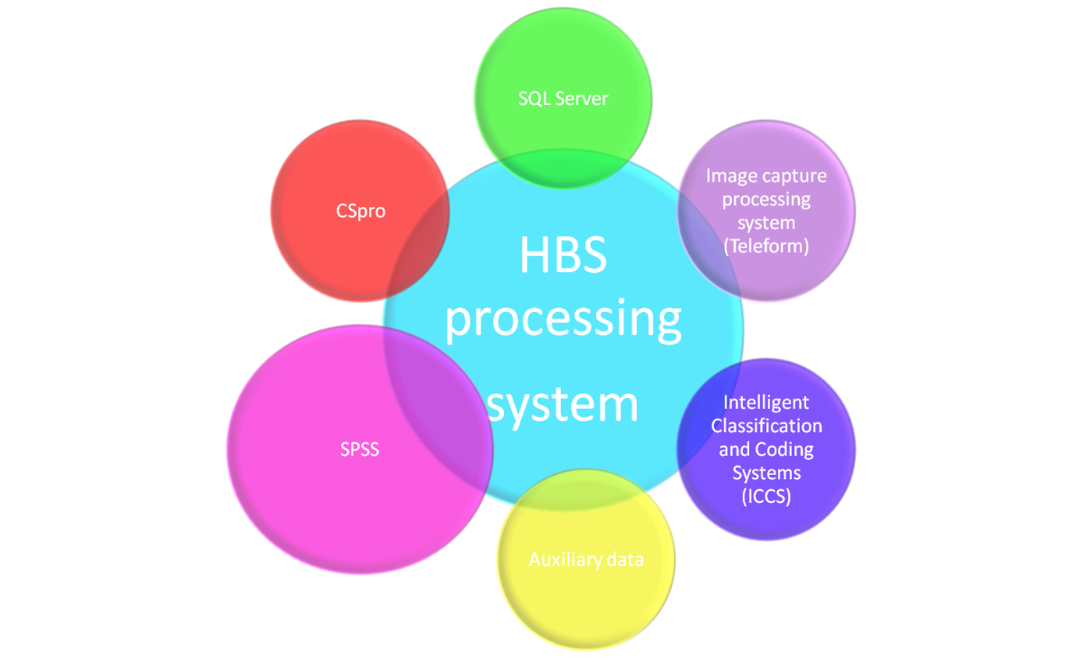

**8.3** **Image Capture System**

Compared to manual data entry, image scanning technology is an alternative data capture method which can be used to capture the raw data of large scale surveys and censuses. This approach lends itself to economies of scale and ensures that the raw data are captured and hence processed in a timely, efficient and cost effective manner. In particular, Cardiff’s TELEform V10 Information Capture System Software, a product of Cardiff Software Inc. was used for the 2008/09 Household Budget Survey. This software consists of a Control Centre and six basic modules.

**(a) The Control Centre:**

The Control Centre is an electronic system manager that helps in troubleshooting and optimising the features of TELEform to the advantage of data processing and comprises five distinct branches namely; statistics, workflow, configuration settings, reports and alert. The Control Centre also monitored the progress of the users and the status of the operations of the other modules.

**(b) Modules:**

Five modules of TELEform which were used extensively during the data capture stage were the Designer, Reader, Verifier, Print Manager and Scan Station. The functions of the five modules are as follow:

**TELEform Designer**

This was used to design and create the HBS questionnaire to collect data through shading Optical Mark Reader (OMR) and writing Optical Character Reader (OCR).

**TELEform Reader**

The Reader evaluates the questionnaire automatically. After identifying a questionnaire, Cardiff RecoFlex recognition technology interpreted machine print (OCR), check box (OMR) and bar code fields. RecoFlex also receive, identifiy and evaluate the scanned images, compares these images with the questionnaire template created in TELEform Designer and linked pages of the same questionnaire as initiated in TELEform Designer.

## TELEform Verifier

The Verifier allows for checking or correcting information that was not evaluated with sufficient confidence by the Reader. The questionnaire can go through one of the three modes of correction, namely the form mode. With this mode, one was able to review and edit the entire contents of all data entry fields, whether or not it was held for review. On completion of this final verification, the batches are ready to be committed. At this stage, the entry point is triggered and the data exported.

**Print Manager**

The Print Manager enabled the printing of the census questionnaires, each having a uniquely generated barcode for identification and testing. In addition, the Print Manager also allowed a PDF copy of the questionnaire to be generated for the printers.

## TELEform Scan Station

The Scan Station processed the images in batches from both the scanner and export directory.

**8.4** **Intelligent Classification and Coding Systems**

The processing operations within the HBS unit were designed so as to minimize manual processing activities while introducing greater automation. Greater automation provided advantages with respect to timeliness, control, reliability and accuracy. Apart from the use of image capture software other systems that were utilized such as on-line access to codes, mortgage calculations and other relevant information as well as the automatic linkage of text and code enabled the HBS processing staff to complete the processing of documents for each period as scheduled. The classification used required a ten digit code for the recording of diary expenditures however these codes were never actually inputted by the processing staff. Text information such as items and area purchased were entered using look-up menus and automatically converted to code.

**8.5** **Hardware Used**

The HBS Unit undertook the data processing activities with the use of the following hardware components.

**(a) Servers:**

A HP Proliant ML370 server and two IBM Server were utilized.

In terms of data security, passwords were used to limit access to files and the data were also encrypted so that unauthorised access did not allow direct reading of the data. In addition, the database was backed up internally on a daily basis and off-line copies were stored at the CSO on a weekly basis.

**(b) Clients:**

Forty computers were connected on the LAN, running Windows XP/Vista and 2000 Professional as their operating Systems.

**(c) Scanner:**

Two Fujitsu Kofax M4099D Image Scanners were used by the HBS Unit to perform the task of data capture. The M4099D Kofax is a very fast and highly functional image scanner developed for volume filing, using charge-coupled device (CCD) image sensors and also featured duplex scanning and high quality image processing with an automatic document feeder (ADF). One flat bed scanner was used for torn pages.

**8.6** **Processing Staff**

The processing staff comprised twenty (20) Editors/Coders/Verifiers and two (2) Scanning Operators supervised by the Statistical Technician II responsible for editing and coding activities working in close collaboration with the IT Specialist I. One (1) Editor/Coder/Verifier was allocated to the work of two (2) Enumerators. These persons were responsible for editing and coding documents, manual data entry of diaries and verification of scanned information. Prior experience in survey processing and computer literacy were necessary requirements to perform effectively in this area.

**8.7** **Number of Documents Processed**

The total number of documents processed by the Household Budget Survey (HBS) processing staff comprised the following:

* 7, 250 Household questionnaires
* 15, 555 Individual questionnaires
* 6,817 Diaries
* 2, 112 Main Food Purchase Forms

**8.8** **Main Processing Activities**

The main processing activities include:

* Editing and Coding
* Batching
* Striping
* Scanning
* Data Entry of Diaries
* Verification
* Validation

**Editing and Coding**

Editing and coding of questionnaires was the first processing activity undertaken. Documents for each period were edited in great detail. Checks were made to ensure consistency and reliability of recorded information. In some cases respondents were contacted via telephone to resolve significant inconsistencies, where certain types of errors were occurring frequently or appeared systemic errant enumerators and their supervisors were called into the office were problems were highlighted to prevent reoccurrence.

**Batching and Stripping**

The questionnaires are stripped and batched in preparation for scanning with each batch containing a specific number of questionnaires. A batch recording system was designed using the Microsoft Access Software to capture basic data such as the type of holding, gender of the holder and the identification of the questionnaires which comprised of the barcode, the region, community and enumeration district codes as well as the list entry number. Other types of information were captured manually from the questionnaire and served as a manual check against the scanned data.

**Scanning**

Scanning involves the transfer of data from the questionnaire to a computer readable media using an automated reading device rather than manual keyboard entry. Utilising both OCR and OMR, batches of questionnaires were scanned using the high speed Kofax 4099D Scanners.

**Data Entry of Diaries**

The diary information was key punched while the questionnaires were being scanned.

#### Verification

(100%) verification was used. Verification required that each verifying officer compared the scanned images of the questionnaire with the actual document to ensure that the scanned image and information on the document were the same.

**Validation**

Validation refers to the process of ensuring that the information contained in the data base is reliable, accurate and consistent. A number of detailed edit and range checks were developed to test the HBS data. Possible errors were identified and corrections made were necessary. The data in the HBS Questionnaires, Diaries and Main Food Purchase Forms were validated.

**8.9** **Gross Imputed Rent**

Gross imputed rent is an imputed value which measures the consumption of housing services by owner occupiers. It was estimated directly from question 7.2 in the Household Questionnaire which asked ‘In the present market conditions, if this dwelling were to be leased or rented unfurnished, how much would it fetch monthly?’ Outliers were identified and adjustments made using a simple regression model.

**8.10** **Other Processing Activities**

**Area Purchase and Cross Communities**

The existence of cross communities i.e. communities that cross regional boundaries continue to present problems were information is collected at community level but must be raised to regions. The CSO has not as yet resolved this problem. To avoid this problem occurring with the area purchased information the area purchase (community) was allocated to only one region in the cross communities based on the location of the main shopping area.

**Tabulation Plan**

A tabulation matrix was prepared and distributed to HBS Stakeholders to obtained input into the final tabulations after which a detailed tabulation plan was developed.

**Non-Responding Spenders**

Expenditure on individual type items were imputed for spenders who were employed but did not respond. Donor spenders with similar characteristics to the non-responding spender were used.

**Scaling and Aggregation**

Information across the various documents were scaled to a month and aggregated to the item level.

**9.1** **Problems Encountered**

The 2008/09 Household Budget Survey was successfully completed as scheduled on the 30th September 2009. The conduct of surveys of this type and magnitude can be quite testing especially given the need to maintain the highest levels of quality and timeliness. Notwithstanding the inherent difficulties there were certain problems encountered which mitigated the success of the exercise. The most significant of these are list below.

**Publicity**

The publicity of the 2008/09 HBS was very disappointing. It comprised a few irregularly placed advertisements which were discontinued after five (5) months into the survey. As a consequence the majority of the households enumerated were unaware of the survey and cooperation was difficult to secure which serve to exacerbate the already difficult environment in which the fieldstaff operated.

**Discontinuation of Tokens**

Tokens were initially given to households who cooperated, however this was discontinued after five (5) months. These tokens proved to be quite useful especially in facilitating cooperation over the two (2) week period of enumeration so much so that some enumerators continued to give out tokens which they purchased on their own account.

**HBS Brochure**

A well drafted, attractive and simple brochure is an important tool used to communicate information about a survey to specific respondents. The HBS unit prepared a draft brochure which was submitted for finalization. However this brochure was never approved or printed.

**Inadequate Financing**

The financing of the 2008/09 HBS operations was vastly inadequate. These operations were planned and organised with a budget of $17,990,464 which was approved by Cabinet. Funds released over the period September 2006 to September 2009 amounted to $12,528,857 resulting in a deficit financing of $5,461,607 or 30.4%. Consequently certain activities were curtailed, the flow of activities was disrupted and the payment of entitlements to staff was delayed.

**Tobago Field Visits**

Planned regular field visits to Tobago by the technical staff of the HBS unit were an important element of the field operations. It was essential for the maintenance of high quality work that enumerators in Tobago received the same expert support as did the Trinidad enumerators and even more so given that no supervisor was assigned to Tobago. Twenty-four field visits were planned so as to coincide with each fortnightly period of enumeration. However approval was received for only twelve (12) such visits.

**Quality of the Enumeration Maps**

Enumeration district maps play a critical role in the location of households to be interviewed. The HBS sample comprised 1,920 enumeration districts. Many of these maps were found to be very outdated, poorly drawn, excluded many buildings, included structures no longer in existence and difficult to follow. These deficiencies added to the problems faced by the enumerators.

**Human Resource Issues**

The majority of persons working on the HBS were contract officers. These persons completed their period of employment without ever receiving any contracts. Consequently they worked without ever knowing their actual salaries or being able to access any benefits under such contracts. Most persons left very disappointed.

**Vacant Position of IT Specialist II**

The position of IT Specialist II was never filled. This represented a serious handicap on the exercise as the IT Specialist II was the most senior position of only two (2) IT positions in the HBS Unit. As a consequent a number of critical IT activities could not be accomplished as originally scheduled adversely affecting the planned sequence and timing of the processing operations. This situation took to long to be addressed despite numerous requests by the HBS Unit for assistance. Eventually some relief was provided late into the exercise via external IT support and an IT personnel to assist the IT Specialist I.

**Quantum of Survey Preparation Work**

The quantum of survey planning and preparation activities required for the successful conduct of the HBS was quite considerable. All of the major HBS documents had to be developed or redesigned given that the existing documents were either, deficient, outdated or non-existent. Principally amongst these were the following:

* Household Questionnaire (Redesigned)
* Individual Questionnaire (New)
* Diary (Redesigned)
* Main Food Purchase Form (New)
* COICOP Expenditure Classification (New)
* Multi-Purpose Control Form (New)
* Field Activity Log (New)
* Enumerator’s Manual (New)
* Editor’s Manual (New)
* Validation Checks (New)

**Sample Frame**

The 2000 Population and Housing Census data formed the frame used for selecting the first stage sampling units. This was the only complete frame available at the time of conducting the HBS. Another possible frame was the Continuous Sample Survey of Population (CSSP) master sample however this source had not been revised since the 1990 Population and Housing Census. Obviously the use of distant (time) frames for sampling is not the best practice.

**Occupation and Industry Codes**

The occupation and industry codes from the 2000 Population and Housing Census were used in the HBS for the coding of occupation and Industry. These codes were inadequate and did not cover many of the occupations and industries reported by respondents.

**9.2** **Recommendations for Improvement**

**Permanent HBS Section**

Household Budget Surveys (Income and Expenditure Surveys) should become a regular and permanent part of the work programme of the CSO. These surveys are now recognised as constituting a critical part of the statistical infrastructure of modern statistical organisations. A dedicated HBS Section possibly within an expanded Household Surveys Section should be created. This would permit development of HBS methodology and related documents as part of an ongoing process instead of the ‘one off’ approach at present.

**Frequency of the HBS**

The frequency of conducting Household Budget Surveys should be increased (the previous HBS was conducted eleven (11) years ago). A full scale HBS should be conducted every five years as is internationally recommended with a smaller scaled HBS conducted annually.

**Sample Frame Maintenance**

A system of population frame maintenance should be developed so that there is not an over reliance on the CSSP frame for drawing samples. This can be achieved by hiring a few additional fieldstaff for listings which in conjunction with the enumeration districts listed in the CSSP would provide moving population updates every two or three years.

**Occupation and Industry Codes**

Occupation and industry coding is often required in many large scale national surveys consequently it is important that these codes be standard, updated and relevant as far as possible. The CSO should create a standing committee with support staff to ensure that these codes as well as their interpretation are standardized and updated.

**Enumeration Maps**

An audit of all enumeration district maps should be conducted and some form of certification/ approval of worthiness on each map introduced. It must be remembered that these maps are often sold to external persons and organisations conducting survey work. These maps have always been a major embarrassment to the CSO.